Callsign Mobile Application Test Plan
Test plan identifier: T4245

Reference: App name: Callsign version:2.2.0(2.0.1-LONG)

- Project plan: Providing a secure app for users example people can share their details such as DOB or bank details without any doubt.

- System Requirement: This app is work just on the latest version of IOS in iPhone and latest version of android.

- Low Level Requirement: This app is only work in latest version of iPhone and HTC or any other phone BUT if it won’t be latest version then your phone may be can get hacked.

- Design : This app design is very simple. you can add a person just by phone number and then later it will come up in activity.
Introduction
This is the test plan for Callsign mobile application. This document explains the testing methodology for a mobile application, and is to be used as a guide for the testing activity. The scope of testing as explained in the document is to test the operating characteristics of an application that runs on mobile devices supporting Android and iOS.
This plan will address the items and elements as listed in the test items. The primary focus of this plan is to ensure that all the functions of Callsign mobile application version 2.2.4.1028.ff8c9c9 (1028) is working fine, identifying any faults with the application, report it back to the developer team, carry out regression testing and close the testing when everything is fixed.
The estimated timeline for this project is 2 weeks, as such, any delays in the development process could have significant effects on the test plan.
Test Items
Callsign App, version 2.2.0 in Emulator
Callsign App for IOS
Callsign App for Android
Callsign website
Software Risk Issues
The following may impact the test cycle:
• Device availability – Android and iOS
• Any new feature addition/modification to the application which is not communicated in advance.
• Any delay in the software delivery schedule including defect fixes. Any changes in the functional requirements since the requirements were signed-off/formulated
Existing Software Risk Identified and needs to be investigated as part of testing in this release:
1. Displays session expired in repeated login attempts:
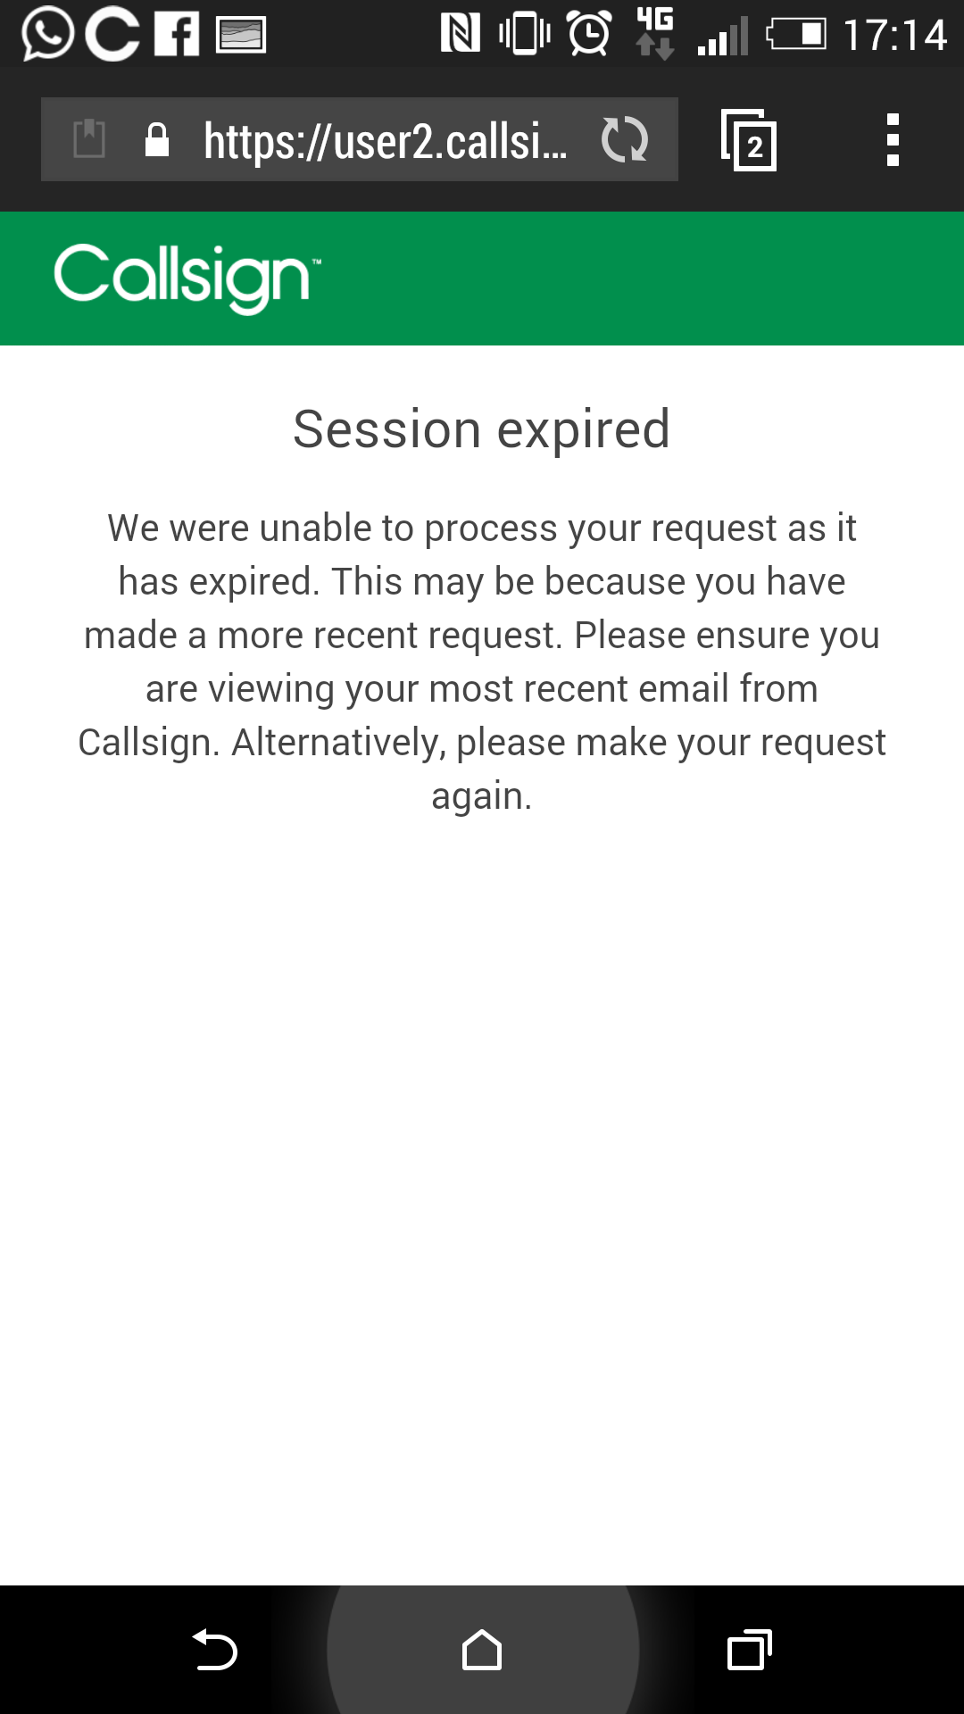

2. Callsign App stopped during the access:
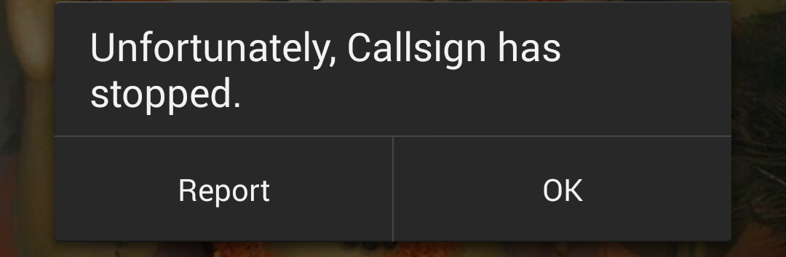

3. While reactivating account, message displayed like poor connectivity and did not send the message:
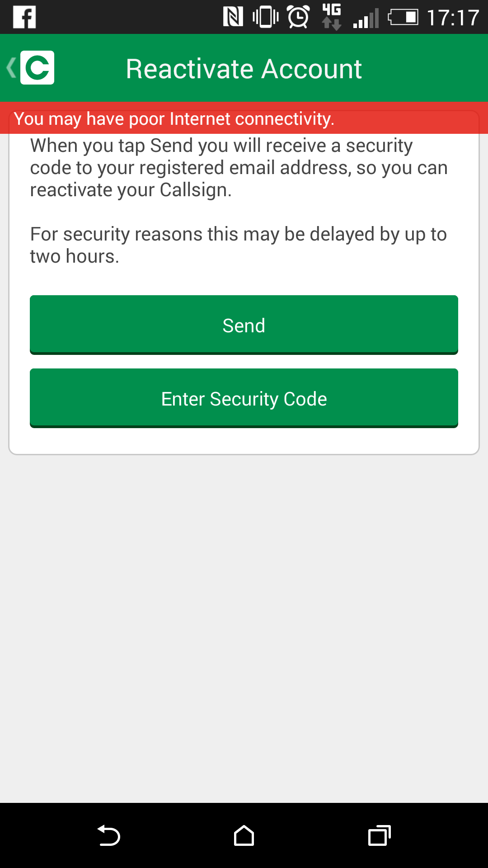

4. Unable to register in callsign due to the same name has registered already:
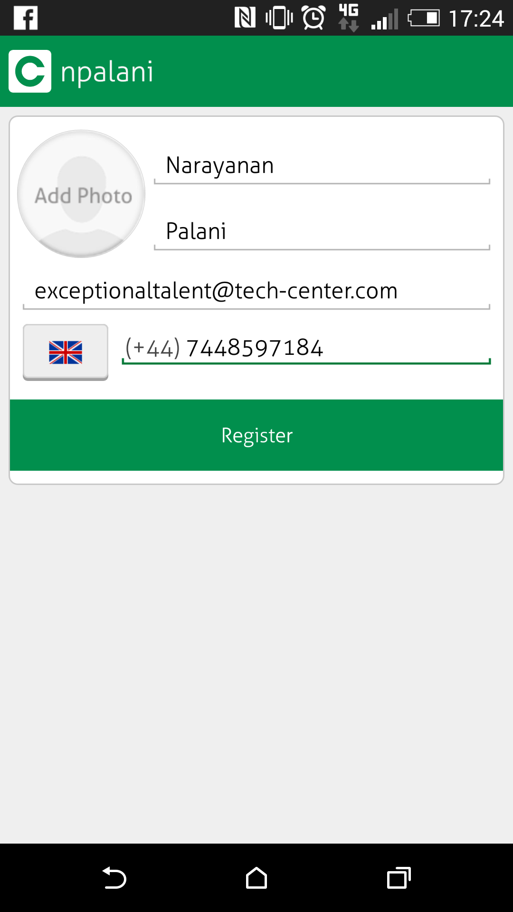
5. Mobile hangs during sms button is pressed:
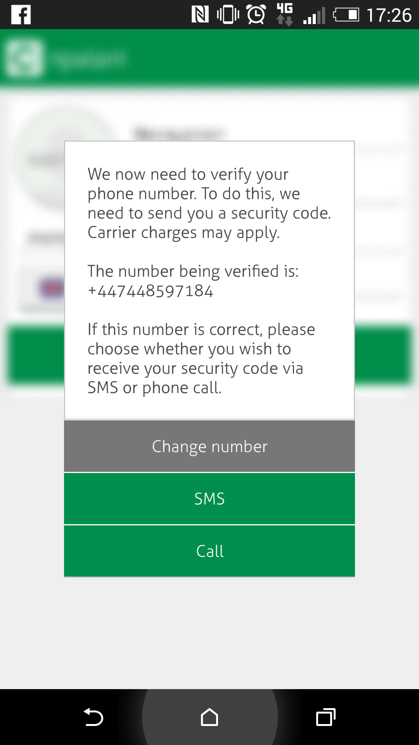

6. npalani is used to register but this is not recognised:
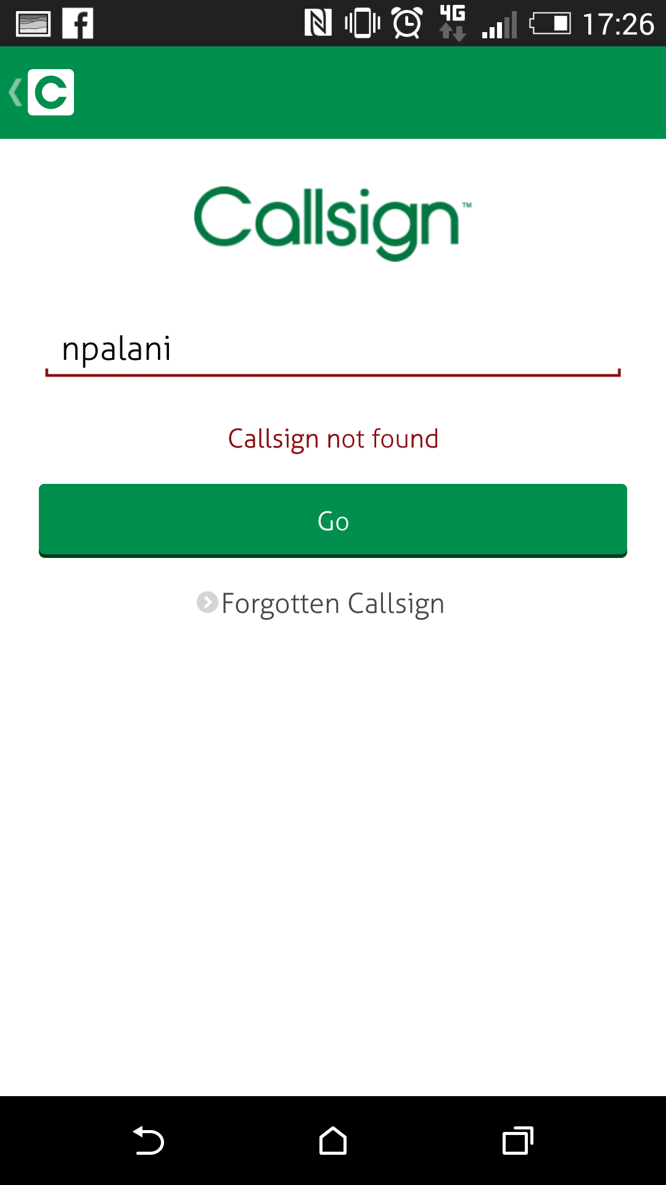

7. After entering the call sign id, Go button is still disabled:
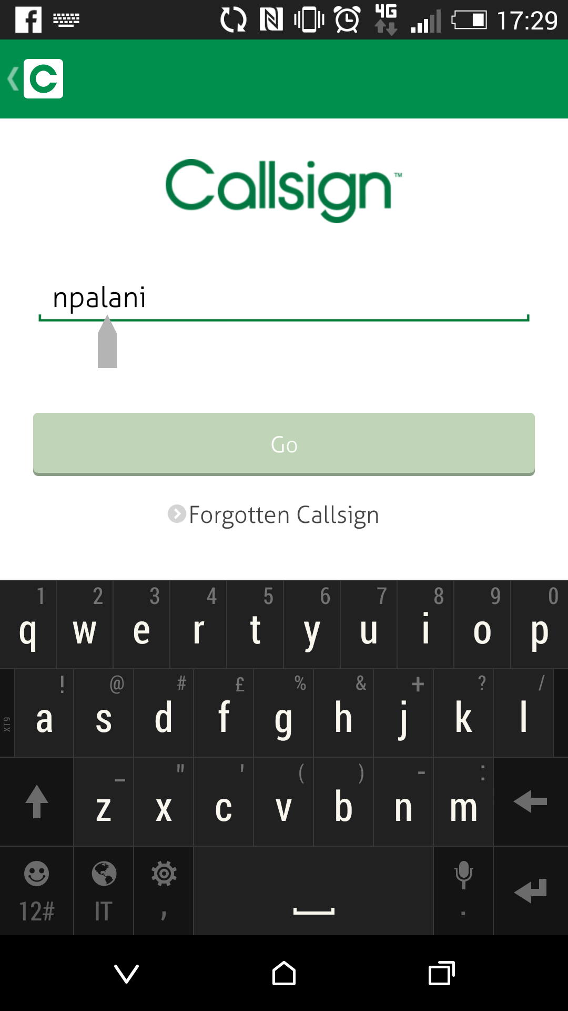
8. Email sent along with ? symbol:
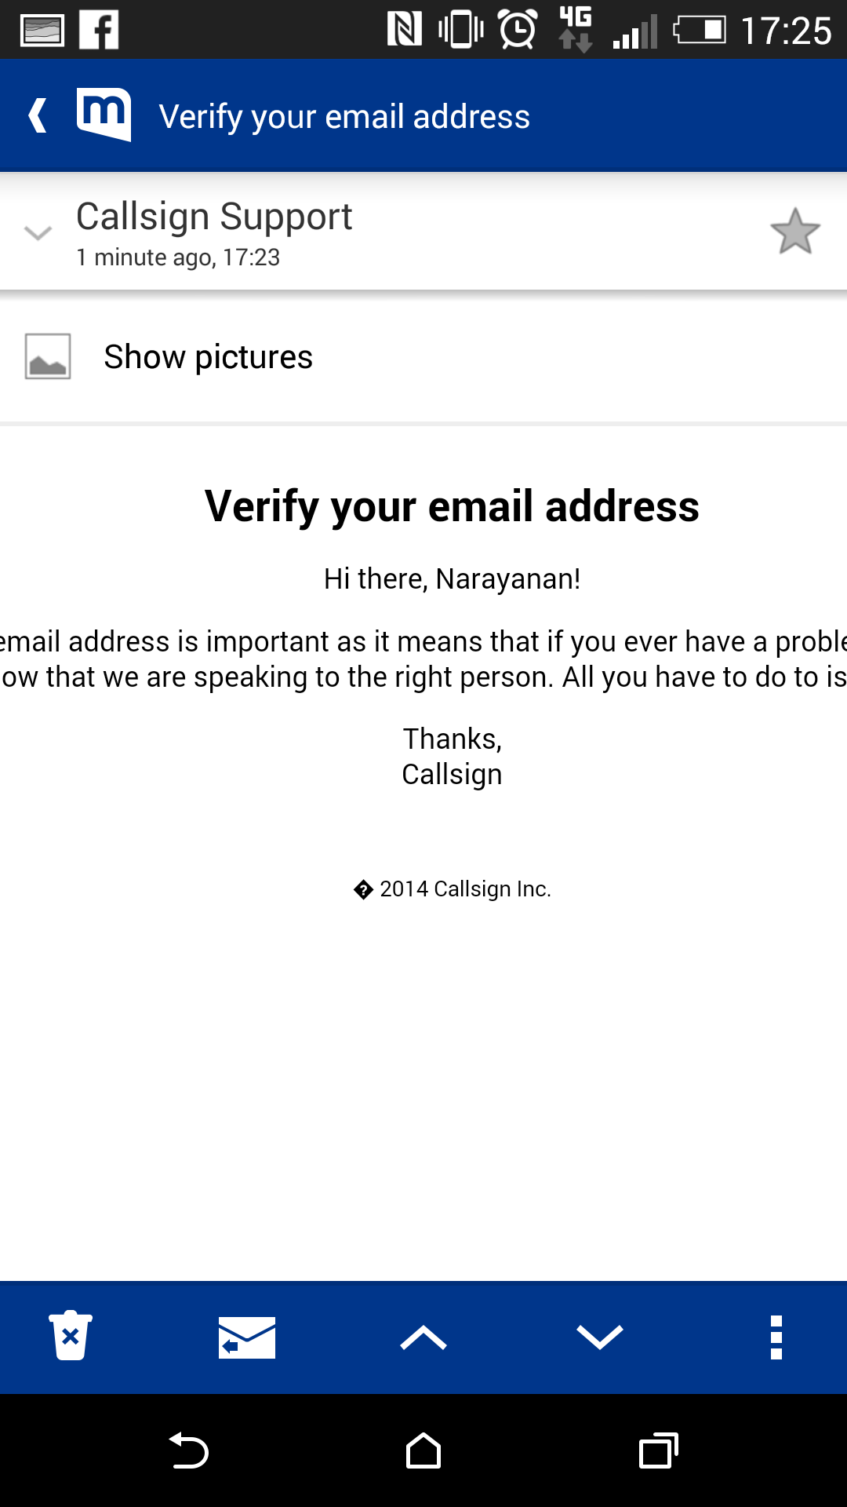

Features to be Tested

The following are the features to be tested that will be performed to the Callsign mobile application version 2.2.4.1028.ff8c9c9 (1028).
- Application Characteristics (AC) – Information about the application is provided to help the testing team in the testing work.
- Stability (ST) – Focusing on the application being stable on the device.
- Application Launch (AL) – Once an application is loaded it must start (launch) and stop correctly in relation to the device and other applications on the device.
- User Interface (UI)
- Operating Characteristics (OP) - of an application that runs on mobile devices supporting Android and iOS.
- Functionality (FN) - Documented features are implemented in the application and work as expected. Sources for the information are user manuals, formatted application specification documents and online documentation.
- Connectivity (CO) – the application must demonstrate its ability to communicate over a network correctly. It must be capable of dealing with both network problems and server-side problems.
- Personal Information Management (PI) - The application accessing user information needs to be able to do it in an appropriate manner and not to destroy the information.
- Security
Test Estimation
Following are the test estimation in MANDAYS:
Product | Resources | Test Design | System Testing | Integration Testing | UAT | Total Duration
Callsign App, version 2.2.0 in Emulator | 1 | 5 | 3 | 2 | 1 | 11
Callsign App for IOS | 1 | 2 | 3 | 2 | 1 | 8
Callsign App for Android | 1 | 2 | 3 | 2 | 1 | 8
Callsign website |  | 2 | 3 | 2 | 1 | 8
 |  |  |  |  |  | 35

Features not to be Tested
Network Security and Service Layer Access
Hardware Assembly (Mobile Phone itself)
Approach strategy
Callsign app is planned to be tested in following mobiles types: Iphone and Samsung as per IEEE standards

Pass/Fail Conditions
It is expected that test cases must pass all the tests in each test category to be successful.
A retest needs to be performed on any test that have failed.
Suspension Criteria/Resumption Requirements
Resumption
- Development of the application is complete
- Successful completion of unit testing for the applications
- Release of software to the test environment
- Dedicated resources are allocated
- Test Cases have been reviewed
- Test environment is up and working
- Build is complete and smoke test has been done.
Suspension
The Following is the criteria when the testing will be stopped for this module:
- The test cases have all been executed.
- At least 95% have passed successfully and The remaining 5% that have failed do not impact critical functionality
- The test results have been evaluated reviewed and accepted.
- There are no showstoppers or high criticality defects unresolved or outstanding
Remaining Test Tasks
Task | Assigned To | Status
Create Mobile Test Framework | Automation Tester
Verify the Mobile Test Resource Plan | Test Manager
Create Test Data Sheet | Test Engineer
Verify emulator prototype | Test Lead
Verify Cloud Computing Environment | Environment Manager

Environmental Needs
The following elements are required to support the overall test at all levels within the mobile project:
- Access to both development and production based emulators and mobile applications.
- An exclusive test environment for performance testing as it should impact the regular test executions of other test cycles.
Staffing and Training Needs

Preferred to have exclusive test resource for performance testing.
All testers need relevant training as it is essential to undergo custom based application training before test execution.
Responsibilities

Responsibilities of the testing team for the project are as follows:

Test Execution Signoff: Test Manager
Test Evidences Signoff: Business Analyst
End of Test Report Sign off: Project Manager

Schedule
Overall mobile testing schedule will be decided with the project manager.

Planning Risks and Contingencies

When mobile devices are not available for testing, emulators should be used

If there is an immediate deployment required for the patch, functional testing need to be conducted on the fly to make sure all the major functionalities are working fine.

As a contingency plan, when the mobile application is failing as part of the testing, earlier version of call sign app needs to be considered for testing

Approvals
Test Plan Approval-CTO

